# **Convolution Neural Networks**



# Coding augmentation with ImageDataGenerator

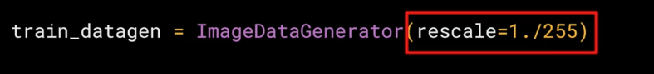

# Coding transfer learning from the inception mode

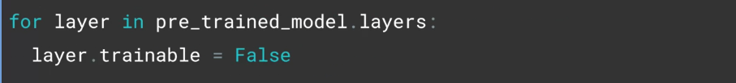

Exploring Dropouts

Before Dropout -

After Dropout -

# Explore multi-class with Rock Paper Scissors dataset

<http://www.laurencemoroney.com/rock-paper-scissors-dataset/>

